SUBMITTED BY

*Rathi.R*

*Reg.no:961819106044*

*ECE ,4th year*

*Ponjesly college of*

*Engineering*

*B12-6A2E*

***DOOR BUZZER USING PIR SENSOR AND PUSH BUTTON***

***CODE:***

***void setup()***

***{***

***pinMode(12, OUTPUT);***

***pinMode(4,INPUT);***

***pinMode(2,INPUT);***

***Serial.begin(9600);***

***}***

***void loop()***

***{***

***int p=digitalRead(4);***

***Serial.println(p);***

***if(p!=0)***

***{***

***for(int i=0;i<500;i=i+10)***

***{***

***tone(12,i);***

***delay(100);***

***noTone(12);***

***delay(100);***

***int a=digitalRead(2);***

***if(a==0)***

***break;***

***}***

***}***

***}***

**TINKERCADLINK:** **https://www.tinkercad.com/things/iOVKnd2hQF7-exquisite-migelo/editel?sharecode=Tar-ONhLLQaCYOUYuVWaxA6ocqFESTJn32u7VHETaSM**

**FIGURE:**

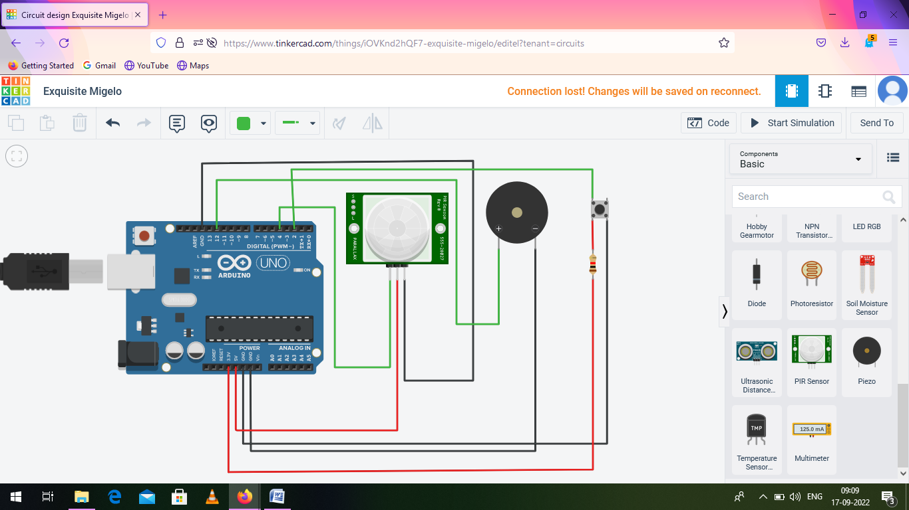

***Whenever anyone comes in the path/range of PIR sensor,microcontroller detects the distance of object is in the defined range,it sends the High signal to the buzzer and buzzer starts beeping.***